

[](http://www.clipartstation.com/clipart_indexer4/index/view?id=20856)[](http://www.clipartstation.com/clipart_indexer4/index/view?id=20910)[](http://www.clipartstation.com/clipart_indexer4/index/view?id=20851)[](http://www.clipartstation.com/clipart_indexer4/index/view?id=20856)[](http://www.clipartstation.com/clipart_indexer4/index/view?id=20910)[](http://www.clipartstation.com/clipart_indexer4/index/view?id=20856)☼☼☼☼☼☼C:\Users\Anton\Documents\Bahai\BAHAIPIC\seto9i_014.gif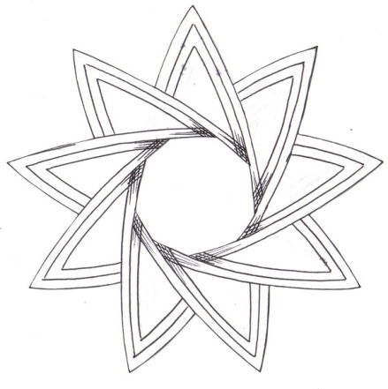C:\Users\Anton\Documents\Bahai\BAHAIPIC\seto9i_014.gifC:\Users\Anton\Documents\Bahai\BAHAIPIC\seto9i_014.gifC:\Users\Anton\Documents\Bahai\BAHAIPIC\seto9i_014.gifC:\Users\Anton\Documents\Bahai\BAHAIPIC\seto9i_014.gifC:\Users\Anton\Documents\Bahai\BAHAIPIC\seto9i_014.gifC:\Users\Anton\Documents\Bahai\BAHAIPIC\seto9i_014.gifC:\Users\Anton\Documents\Bahai\BAHAIPIC\seto9i_014.gifC:\Users\Anton\Documents\Bahai\BAHAIPIC\seto9i_014.gifC:\Users\Anton\Documents\Bahai\BAHAIPIC\seto9i_014.gifC:\Users\Anton\Documents\Bahai\BAHAIPIC\seto9i_014.gifC:\Users\Anton\Documents\Bahai\BAHAIPIC\seto9i_014.gifC:\Users\Anton\Documents\Bahai\BAHAIPIC\seto9i_014.gifC:\Users\Anton\Documents\Bahai\BAHAIPIC\seto9i_014.gifC:\Users\Anton\Documents\Bahai\BAHAIPIC\seto9i_014.gifC:\Users\Anton\Documents\Bahai\BAHAIPIC\seto9i_014.gifC:\Users\Anton\Documents\Bahai\BAHAIPIC\seto9i_014.gifC:\Users\Anton\Documents\Bahai\BAHAIPIC\seto9i_014.gifC:\Users\Anton\Documents\Bahai\BAHAIPIC\seto9i_014.gif



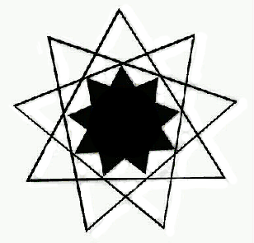C:\Users\Anton\Documents\Bahai\BAHAIPIC\AJOUR.TIFC:\Users\Anton\Documents\Bahai\BAHAIPIC\AJOUR.TIFC:\Users\Anton\Documents\Bahai\BAHAIPIC\AJOUR.TIFC:\Users\Anton\Documents\Bahai\BAHAIPIC\AJOUR.TIF

